MEASURING DISTANCE OF THE OBSTACLE USING ULTRA SONIC SENSOR WITH ARDUINO UNO

TASK- 1

DONE BY:

RAJALAKSHMANAN C(E0219054)

SWARAN S(E0119015)

RETHICK PAVAN S(E0219020)

PRANAV KUMAR JAIN(E0119005)

***Steps***

1. Domain-Data to be collected :

Domain is a data centric IOT , the data to be collected from the ultrasonic sensor to measure the distance.

1. Platform:

The platform is Microsoft Excel

1. Category-Input and Output devices:

The category is short range wire connected device.

Input device – Ultrasonic sensor

Output – Excel Sheet

1. Components Required:

Arduino , ultrasonic sensor , jumper wires, BREAD board.

1. Circuit Connection:

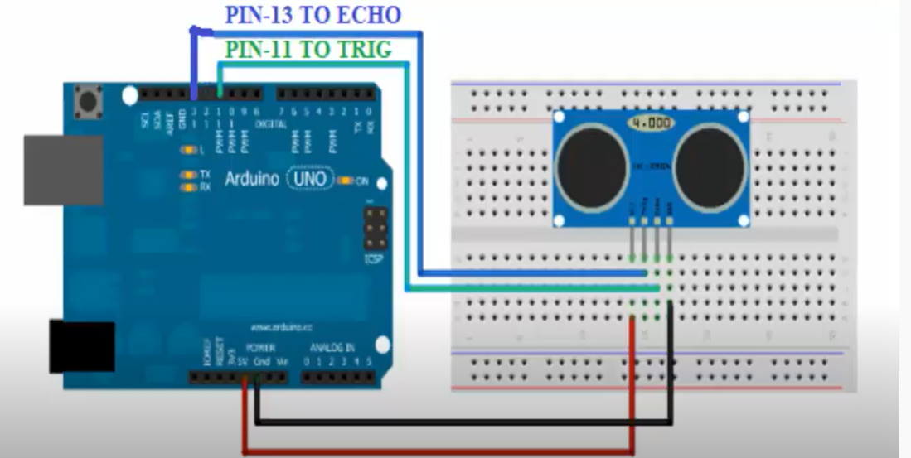

6.CODING:

int trigPin=13; //Sensor Trip pin connected to Arduino pin 13

int echoPin=11; //Sensor Echo pin connected to Arduino pin 11

float pingTime; //time for ping to travel from sensor to target and return

float targetDistance; //Distance to Target in inches

float speedOfSound=343; //Speed of sound

void setup()

{

Serial.begin(9600);

pinMode(trigPin, OUTPUT);

pinMode(echoPin, INPUT);

Serial.println("CLEARDATA");//clear excel sheet

Serial.println("LABEL,current time,Distance in cm");//label for ms-excel

}

void loop()

{

digitalWrite(trigPin, LOW); //Set trigger pin low

delayMicroseconds(2000); //Let signal settle

digitalWrite(trigPin, HIGH); //Set trigPin high

delayMicroseconds(15); //Delay in high state

digitalWrite(trigPin, LOW); //ping has now been sent

delayMicroseconds(10); //Delay in high state

pingTime = pulseIn(echoPin, HIGH); //pingTime is in microceconds

pingTime=pingTime/1000000; //convert pingTime to seconds by dividing by 1000000

targetDistance= speedOfSound * pingTime;//distance=speed*time

targetDistance=targetDistance/2;//waves is traveling twice

targetDistance=targetDistance*100;//convet m to cm

Serial.print("DATA,TIME,");

Serial.println(targetDistance );

delay(1000);

}